
Tripoli Motor Testing Division
223 NC Highway 54 West
Chapel Hill, NC 27514
(919) 357 5681 (c)
April 16, 2024

Scott Kormeier
Loki Research, LLC
119 Mowrey Ln.
Theodosia, MO 65761

Dear Mr. Kormeier,

The Loki Research J-670LB reload kit was tested on March 30, 2024 and complies with NFPA 1125. The motor is certified for hobby rocketry use by the members of the Tripoli Rocketry Association and all approving organizations with reciprocal certifying agreements.

Motor Manufacturer Loki Research, LLC
Manufacturer’s Designation J-670 Bates [made for the 54/1200 hardware]
Propellant Loki Blue
TMT Nomenclature 1270 J670

Diameter 2.126” 54.00 mm
Overall Length 14.031” 1382.7 mm
Outside the MMT 0.39” 82.55 mm

Loaded Mass 2.654 lb 1204.16 g
Propellant Mass 1.274 lb* 578 g*
Burnout Mass 1.511 lb 685.19 g
* = data provided by manufacturer

Burn time 1.891 ± 0.021 sec

Total Impulse 285.47 ± 0.69 lbf.s 1269.8 ± 2.7 N.s

Max Impulse 185.28 ± 11.74 lbf 824.15 ± 52.22 N
Average Impulse 150.60 ± 2.1 lbf 669.88 ± 9.33 N

Number of Motors Tested 3

Nominal Measured
Delay Time Data n.a. n.a.

Casing Temp. [NFPA 1125 7.4.1] Passed

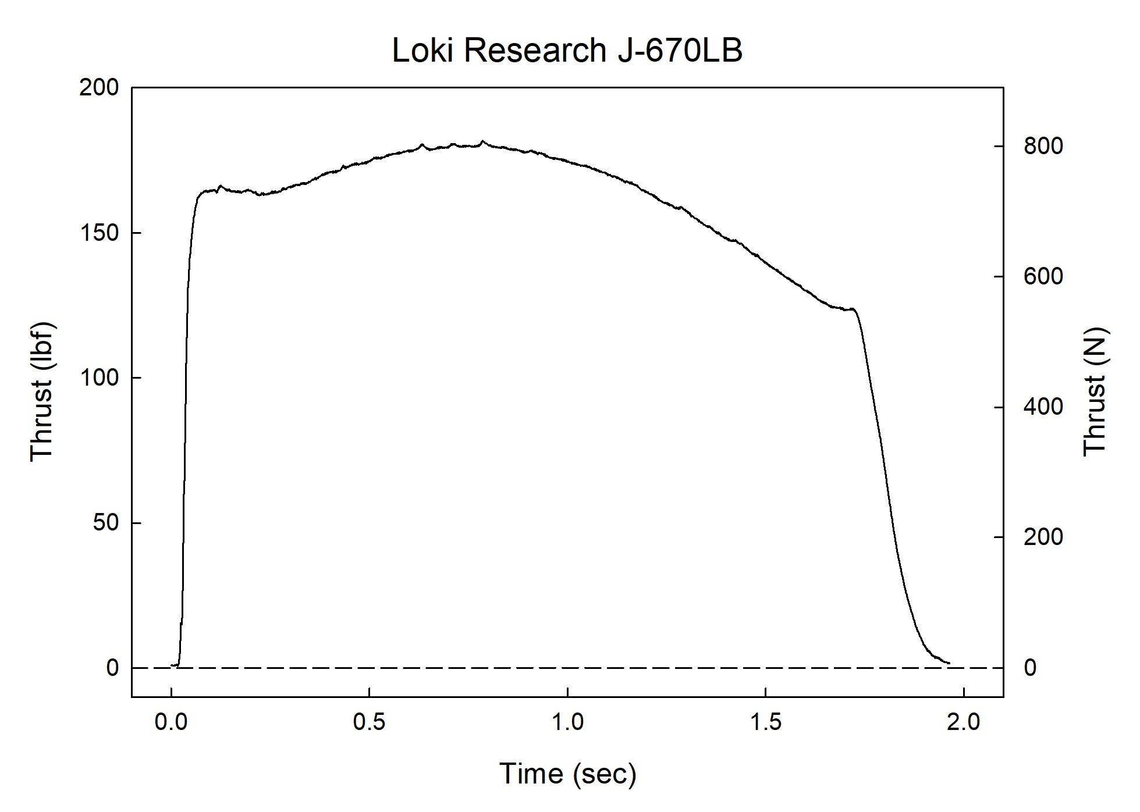

Sincerely,

Alan C. Whitmore
Chair, Tripoli Motor Testing

